Loops, Grooves and Creativity
Investigating Improvisation and Uncertainty within Music Games

Introduction
This essay will look to explore how a music game can implement ideas of uncertainty and improvisation while still remaining a closed, ruled system, using the example of the digital game Session. Starting by defining what a music-game is and some of its sub-types and characteristics, the essay will then go on to suggest ways in which Ableton Live’s interface can be used as a model to allow games to push the boundaries of the genre and investigate potential hybridisation between the sub-genres. From there, the essay will first explore the concept of uncertainty, before developing further to interrogate the concept of improvisation, and how Session has attempted to implement both of them and the problematics that arise from doing so.
Defining the Music Game
Much like music itself, the concept of a music game is broad and has many permutations. In order to discuss Session in context, it is necessary to clarify in what ways the game engages with this genre alongside the ways it attempts to break away from its conventions. The first step then must be to investigate the genre itself. Karen Collins in the chapter Popular Music and Video Games from Game Sound, posits:
Games where music is the primary driving motive or narrative element can be roughly divided into three categories: musician-themed games, creative games, and rhythm-action games. It is possible for these categories to overlap; however, there are often distinct goals or intents behind these types of games.
By Collins’ definition, ‘musician-themed’ games largely revolve around their characters, who are often real-world bands or artists, citing the classic Atari game Journey’s Escape, which follows the band Journey as they attempt to reach their next gig, dealing with crazed-fans and hangers-on along the way. Collins notes a focus on these real world artists’ own music catalogue and personalities, with the games often used as promotional tools for the artists represented (album launches, tours etc.). (Collins 2008, Pg. 112.). In some cases, this extends to the games themselves containing exclusive content, or at the opposite extreme, revolving around simply the personalities and forgoing their music entirely. Some more recent examples of this style of game include Brütal Legend, revolving around Jack Black, with cameos from the likes of Ozzy Osborne, members of Judas Priest, Lita Ford, and the late Lemmy Kilmister, and Iron Maiden: Legacy of the Beast, designed around the eponymous band and its accoutrements. Both of these more modern examples don’t cleanly follow the tropes of this genre sub-type, however. In the case of Brütal Legend, it is Jack Black playing the role of Eddie Riggs, a roadie, not a musician per-se, nor does the game prioritise ‘Jack Black’ the person, but rather Jack Black is just a comedic actor playing a role within the game. Certainly, Eddie Riggs is a caricature of Black, and draws elements from many other roles he has portrayed (his work with Tenacious D, most notably), but it is still a distinction to note that it is a character unique to the game being presented – albeit clearly influenced by other elements - and not Black himself. Legacy of the Beast is perhaps more in-keeping with Collins’ definition, but plays with the concept of ‘musician’-themed, by having its main character(s) be designed around Eddie, Iron Maiden’s mummified mascot. While certainly a well-known icon of Iron Maiden, and a regular part of their album artwork and stage shows, he is not a member of the band, nor is the game focusing on a real-world personality. Conversely this allows the game to fully embrace Iron Maiden’s mythological and fantasy leanings, and still works as a promotional tool through the use of their mascot and their music present within the game.
Session fits awkwardly into the musician-themed game sub type. While the game does revolve around a session band, and indeed the world of touring and gigging, the band itself is faceless, ageless and genderless save for what the player projects onto the game; performative in the vein of what Judith Butler describes in ‘From Interiority to Gender Performatives’. In that sense, the game does not revolve around a real-world musician or figure, nor is it used (currently) as a promotional tool for external music or other media. However, some parallels can be drawn with the way Brütal Legend interacts with the sub-type, in that Session’s narrative and mechanics offer a stylised look into the life and work of musicians and stage crew – though without the fantasy combat.
More prudent then, is to look towards Collins’ other two definitions. ‘Remixing, production, and composition of original songs,’ are core components of creative music games by her definition, looking towards games like MTV’s Music Generator. (Collins 2008, 112). More esoteric examples include Electroplankton and (to some extent) Seaman and its creative use of microphone inputs. Session certainly fulfils more of these criteria, with the game’s mechanics heavily based around successful manipulation of ‘clips’, an internal system of loops based heavily on Ableton Live’s interface, creating a gameplay loop of real-time remixing. Arguably, this also allows the Player an active role in composition, with their choices and decisions affecting the overall structure, dynamics and timbre of the song at any given moment. Rhythm-action games, on the other hand, necessitate the Player co-ordinating ‘actions to a beat or melody in a game.’ (Collins 2008, 113). Obvious examples include Guitar Hero and the infamous arcade game Dance Dance Revolution, alongside recent VR sensation Beat Saber. The focus on the correct input, at the correct time with little room for error is a mainstay all three of these titles: precision is key in playing the right note in Guitar Hero, hitting the right dance move for DDR, or slicing the incoming block in Beat Saber. This inherent inflexibility in what these games consider the ‘correct’ player input is a direct consequence of said games being tied so heavily into ‘rhythm’ as a core concept. In turn, this limits creativity and musical expression; one has to play/perform the song as written. In this regard, the design of Session attempted to circumvent or at least alleviate this rigidity, by only allowing changes in clips at the beginning of a loop and not immediately upon selection, and also offering multiple ways to appease the audience. For example, if the crowd wants a green ‘Groove’ clip, then the Player has four different options to meet that demand. This both reduces the rhythmic demands placed upon the player, and simultaneously offers them greater agency. However, it is important to recognise that a reduced reliance on rhythm and precision is not its removal. There are still time and rhythm constraints implicit in the beginning/end of a loop being the sole opportunity to restructure what clips are playing, and the spectre of the worsening ‘Crowd Vibe’ over time if the audience’s desires are not met.
A more tangential element of rhythm-action games is their increased fidelity to performance. Games are ergodic; they require non-trivial input from their players in order to be traversed, ‘works in motion’ that are incomplete artefacts without that input, as articulated Espen J. Aarseth. There is, in other words, an element of performance required. Furthermore, there have long been arguments to view computer screens as virtual stages, games as theatre productions, most saliently covered by Brenda Laurel. In a game like Guitar Hero, or DDR, the increased levels of ergodicity required to traverse the frenetic deluge of incoming notes or dance-moves more closely maps the experience of performing that act in the real-world. The precision and rhythm required of one echoes the other. Salen and Zimmerman argue for the ‘immersive fallacy’:

… the idea that the pleasure of a media experience lies in its ability to sensually transport the participant into an illusory, simulated reality. According to the immersive fallacy, this reality is so complete that ideally the frame falls away so that the player truly believes he or she is part of an imaginary world.’
If we take immersion (however contentious its definition may be) to be a diminished critical distance to the subject coupled with an increased emotional involvement in what is happening, then Salen and Zimmerman’s concept of the immersive fallacy and its participatory, performative nature resonate heavily with Aarseth and Laurel. Play is immersive, and the closer that play is to the actions represented the more immersive that experience is. In a game that deliberately mimics the rhythmic, precise actions of the musician or performer, and embraces the theatrical, stage-esque performative qualities of the computer screen in its level design and narrative, surely there is greater room for immersion? Certainly, games like Guitar Hero and other rhythm-action games attempt to index into this.

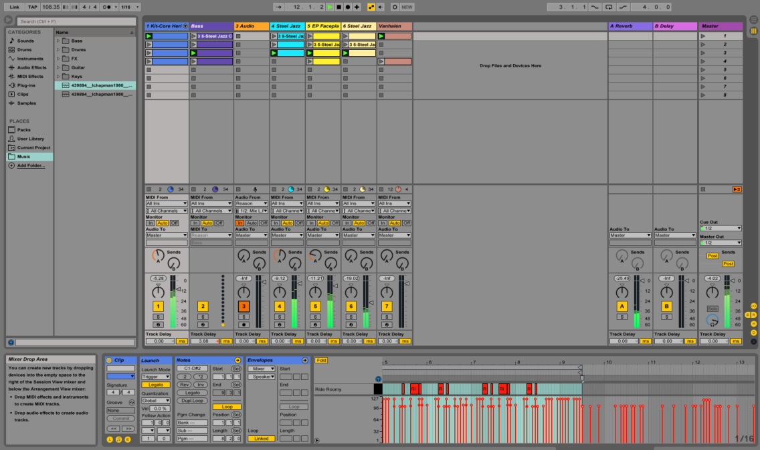
Figure 1: Ableton Live and its Clip System, playing the Session live set

The Ableton Interface and the Digital vs. Analogue Conundrum
With this understanding of music-game, it becomes more obvious where Session sits within the genre. While the game does draw elements from the musician-themed sub-genre, particularly in terms of its narrative content, it is much more clearly situated within the creative and rhythm-action sub-genres. Session largely revolves around the ‘remixing, production, and composition of… songs,’ even if the originality of the music is up for debate, and this manipulation and composition of music is done by co-ordinating ‘actions to a beat or melody in a game,’ which ties it into the rhythm-action archetype as well. (Collins 2008, Pg. 112-113). This hybridisation of genre is a deliberate choice in game design. By opening up what are considered viable ‘actions’ for the player as they interact with the rhythm and melody in the game, rather than dictating a universally ‘correct’ action, opportunities for creativity are made more available. In short, the ‘actions’ of the rhythm-action sub-genre are remediated into being the ‘remixing, production, and creativity’ of the creative sub-genre.
One of the mainstays of how Session attempts this hybridisation is through its clip interface. Designed around Ableton Live’s own clip interface (see: Fig. 1), Session’s system allows for synchronised loops and live manipulation of those loops. However, it does lead to its own problematics. The age old debate between analogue and digital, continuous and discrete, once again rears its head. The negotiation between these two juxtaposed poles is of paramount importance in the world of music, as reasoned by Daniel Heller-Roazen, who at once notes ‘the irrational elements of musical temperament, amplitude and timbre that defied all attempts to render them discrete and orderly, necessitating the construction and abandonment of epistemological frameworks’ when discussing Pythagoras and the legend of his forge, and yet also focuses on Boethius. Boethius draws a distinction between magnitudes, which are continuous and ‘not distributed in separate parts’, versus multitudes, which are ‘as a flock, a populace, a chorus, [a] heap of things,’ containing multiple discrete elements that are enumerable. By Boethius’ definition, music is ‘the science of multitudes in terms of their shifting relations,’ set alongside arithmetic in medieval cannon. It is from this discordant, opposed synchronicity – the continuous discrete - that the concept of the musical note, and from there the musical ‘key’ was developed. (Moseley 2016, Pg. 79). In defiance of music’s irrationality, the note is a discrete depiction of sound, the key unlocking its pitches and encrypted meaning. The keyboard then is a re-materialisation of these symbols:
If the lattice of the staff enabled the quantification of musical duration and frequency, and thereby coordinated assembly and transmission of otherwise inconceivable polyphonic structures, then this grid was most directly materialised by the keyboard’s matrix. (Moseley 2016, Pg. 81).
The keyboard, a ‘discrete continuum’, becomes a way of digitising music, in that digital communication concerns itself with the transmission of information that can be measured, combined and compressed. The keyboard is a digital interface, conjoining the mathematical and musical by ‘facilitating human involvement in computational processes’ – ‘the most glaring possible opposites of human thought! and [sic] yet connected, mutually sustained!’ (Moseley 2016, Pg. 102).

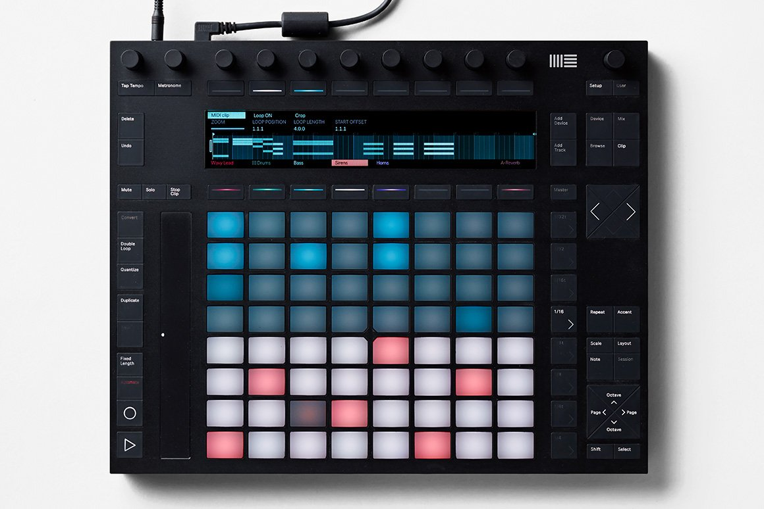
Figure 2: Ableton's Push 2 - a hyper-modern launch pad designed for use with Ableton Live

What defines a ‘keyboard’ has long since evolved; one only has to use a computer keyboard to witness that, and Moseley’s extended genealogy within Keys to Play elucidates on this. A further evolution of the ‘keyboard’, or rather the digital interface, has been the birth of the ‘launch pad’, and to link directly to Session, Ableton Live’s launch pad and digital interface, the Push. (See: Figure 2.). Gone is the linear continuity of the traditional keyboard, replaced instead with an abstract grid with few defining features, barring the LED glow of individual keys. If the keyboard was a remediation and spacialisation of traditional notation, then the launch pad is a remediation and spacialisation of the traditional keyboard. Critically, no longer is one key a defined note; they are mutable, or not even a singular note at all. This abstraction of both form and function carries forward into Ableton Live as well. While the Push can be used to play a singular virtual instrument, it is more powerfully used to orchestrate and launch Ableton’s clips; no longer a note but a loop, a groove, a riff. To abstract even further, one can play the virtual version of the digital interface, bypassing the tactile analogue of traversing the physical instrument, instead simply clicking on the desired clips. This variability is at once an increase in digitalisation, with tightly controlled, compressed and translated loops quickly conveyed by the press of a button, and yet inherently less discrete. While a singular loop or clip may remain constant, remaining discrete within the confines of itself, the grander variability of what a loop may be, or what key produces what sound adds uncertainty, mutability. There is no ‘middle c’; one key does not invariably play the same, singular tone. Rather, loops are often complex combinations of notes and tones, more involved, more versatile, and therefore less discrete.
This versatility is a powerful tool towards the hybridisation of genre Session aims for between creative and rhythm-action games, offering creativity and the permeability of the continuous within the discrete confines of the digital interface. It also allays some of the fears and backlash around the ‘anxiety of the dehumanising effects’ of digital music and recording, and its mechanical, unnatural qualities, or conversely the potential loss of the ‘sacred’ within a piece of art or music, making it mundane and too mortal, as put forward by Walter Benjamin. (Moseley 2016, Pg. 84). Digital’s lack of lifelike qualities can make it robotic, mechanical, and yet if it tries to emulate them it can veer into the uncanny valley. Analogue, for example, cannot record silence; it does not a have a ‘no’ function like digital. It is a fine line to tread then between avoiding the unnaturalness of mechanicity and the unnaturalness of falsified life. By lessening the discreteness of what an individual key entails (replacing a singular note with a clip), and offering multiple permutations of a song through multiple interchangeable loops, the sometimes stifling precision of digital media can be reduced, and some of the variable, lifelike qualities of analogue can be introduced without – hopefully – entering into the uncanny valley. This doubles down to affect gameplay as well in Session’s case: by varying the music the player gets to vary the gameplay and outcomes, thus avoiding similar issues in that sphere.
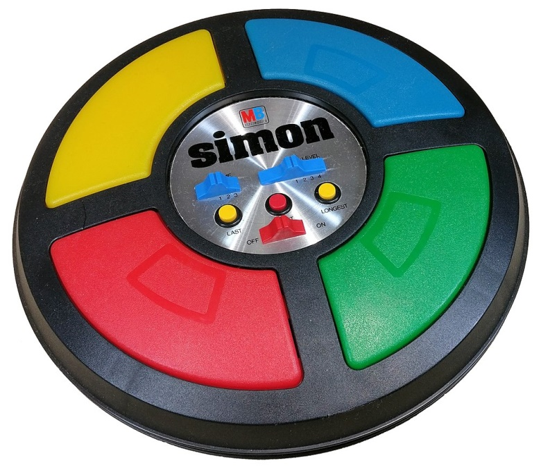
Figure 3: The game Simon - utilising colour and music as tools in a memory game.
Adding Familiarity to the Abstracted Interface
By pulling away from the rigidity of the keyboard, while removing the necessity for one note for one key, also pulls away from a known quantity. Keyboards are, at least to the mildly musically knowledgeable, universally well known. To abstract the keyboard and music into a clip system can therefore prove a challenge for the uninitiated player of Session to parse and comprehend.
One way around this is to utilise concepts from other areas to aid in memorisation and learning. Roger Moseley and Aya Saiki offer an unusual take on teaching players new modes of musical interaction:
Within the mythos of the Legend of Zelda franchise, musical instruments (such as the eponymous Ocarina of Time from the N64 game) perform supernatural functions such as warping through time and space, unlocking sealed gateways, and healing physical and psychic trauma. These functions are activated through the reproduction of sequences of notes imparted to the player after the fashion of memory games such as Milton Bradley’s iconic Simon.
Moseley and Saiki’s comparison between the methods of Ocarina of Time and Simon is a useful one. The abstraction between music and its supernatural result within Ocarina is a challenging obstacle for a game designer to traverse; how does one convey this abstraction? Moseley and Saiki’s answer is to look to Simon, one of the original memory games, which ties patterns to memory with the aid of music, colour and an element of spatial location. The player of Ocarina is taught to play the ‘instrument’ of the N64 controller – something which was a deliberate design goal of the game. (Moseley and Saiki 2014, Pg. 55). Session has a similar conundrum, but it is inverted from that of Ocarina of Time. Where The Legend of Zelda instalment has a ‘normal’ instrument in the ocarina producing abstract supernatural results, Session has an abstract instrument interface of coloured clips producing normal music and loops. Lessons from Simon and how they are implemented in Ocarina of Time are still applicable to Session nonetheless. Simon’s careful construction of tones are always designed to be harmonic, and are designated a distinct colour and location: blue, upper-right is an E; green, lower-right is also an E, but octave lower than blue; red, lower-left is an A; and yellow, upper-left is a C#. (See: Figure 3.). This formation of an A major triad in second inversion resembles a trumpet fanfare. Similarities can be seen to the traditional keyboard: a discrete, visual and physical representation of individual tones, albeit at a limited, four note scale. The two major elements here that are drawn on in Session are Simon’s use of colour and physical placement to aid in memorisation and accessibility of the interface to players. Clips are deliberately placed in row by colour and column by instrument, offering a physical map to aid in memorisation. Similarly, clips are given a distinct colour based on their ‘type’: green for groove, orange for funk, red for style, and yellow for quirk. This dual stratification by instrument and type aids in player memorisation, and also improves accessibility to an otherwise potentially opaque interface. Furthermore, this also synergises with the audience’s demands, who proclaim their needs and wants using the same colour system. All of this can be seen represented in Figure 4. This is also a departure from Ableton Live’s interface, which generically has a colour assigned to an instrument or track, and not stratifications of colour across tracks (it is worth noting however, that clip colours can be manually adjusted in Ableton). This adjustment is a very necessary one in order to improve clarity and comprehension of a system that doubles as both an instrument and interface, and helps lessen the potential learning curve of its abstract nature.

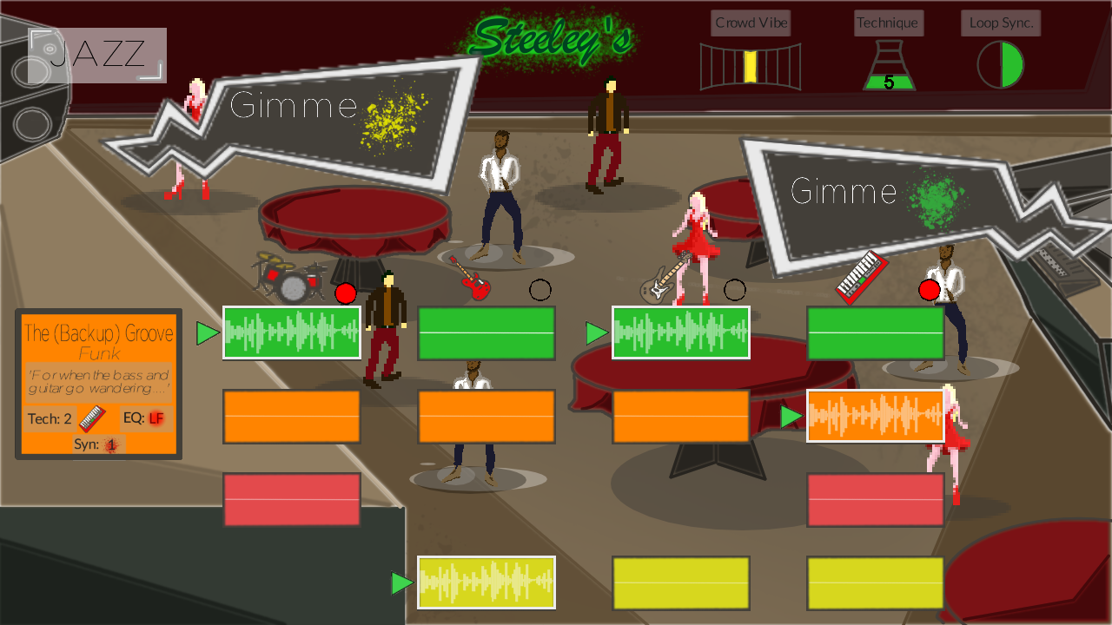
Figure 4: A busy night at Steeley's, Session's seedy jazz club.

Play and the Importance of Luck
Having contended with the issues and opportunities of an abstracted interface, it is now possible to investigate how to implement and utilise that interface. Roger Caillois in Man, Play and Games declares that play requires uncertainty:
3. Uncertain: the course of [play] cannot be determined, nor the result attained beforehand, and some latitude for innovations being left to the player’s initiative.
If games are taken as a privileged form of play, as discussed by Miguel Sicart, then uncertainty becomes a core component of games as well. What Caillois categorises as alea, ‘all games that are based on a decision independent of the player, an outcome over which he has no control,’ includes the likes of roulette, dice and lotteries. (Caillois 2001, Pg.17). Following from this, if, as Caillois asserted, the result of play must not be knowable in advance, a paradoxical question emerges: ‘how can uncertainty be guaranteed?’ If we take Caillois’ examples, all of them rely on ‘rigid formal or material constraints that resist manipulation by the player… by denying access to crucial elements of information and control, which are instead distributed across the ludic system.’ (Moseley 2016, Pg. 127). It is this denial of information and control that allows for systematic uncertainty, or at least unknowability. Alea stands in opposition to agôn, Caillois’ category of heavily ruled, strictly delineated games of contest. All players are well aware of their bounds and in what manner they are testing their skills; most sports, for example. A further stratification is made between paidia and ludus, turbulent, free improvisation at one extreme set against arbitrary, constraining conventions at the other. (Caillois 2001, Pg. 13 - 14). The distinctions here lie between the known quantity and the unforeseeable, the open ended and the tightly regulated; once again, a tension between the discrete and the continuous. The questions posed by these opposing, conflicting ludic drives are challenging to navigate, but Moseley takes Caillois’ system and argues:
Games… can pose, simulate and reframe these questions in ways that reveal how seemingly insignificant differences in parameter or the making of a decision can have far-reaching and unintended consequences. The structure of games brings together the ostensibly opposed elements of necessity and arbitrariness in the form of rules that are finely tuned to give rise to events that are at once explicable and unforeseeable. Analogously, improvisation models and emulates the emergence of complex phenomena from relatively simple rules and materials. On its most ambitious scale, the variation and selection of such emergent processes can be mapped on to the evolution of life itself. (Moesely 2016, Pg. 127).
By removing control and information from the player, a game designer introduces uncertainty and the unknown into a system. There is no longer a ‘perfect answer’ or decision a player can make. One of the problematics with the traditional rhythm-action genre is the lack of alea-based games, or uncertainty in general. In games like Guitar Hero or Rock Band, notes are played in a consistent, expected order travelling toward the player down the ‘note highway’ – there is no inbuilt variation. Similarly, creative type music games like Music Generator or Electroplankton, while inherently designed around versatility, are not necessarily designed around variability. There are many options, but their outcomes are already known. Even in the abstract, underwater playground of Electroplankton, it is possible to work out with a high degree of certainty what outcome will be the result of your actions. This lack of the uncertainty can make music games predictable, and limits the opportunity for the emergent gameplay Moseley alludes to.
Session attempts to contend with this dearth of surprise and uncertainty via its clip interface and how the player uses it to interact with the in-game audience. Taking Moseley’s assertion that ‘seemingly insignificant differences in parameter or the making of a decision can have far-reaching and unintended consequences,’ and that these parameters are formed from the opposing dualities of ‘necessity’ and ‘arbitrariness,’ thus creating the rules of a game, Session looks to foster emergent gameplay by allowing room for these parameters to affect gameplay outside of the player’s control and knowledge. Currently, at the highest difficulty setting of Session (eponymously named, Session difficulty), there are three crowd desire bubbles that are active at any given moment and eighteen variations of crowd desires that can be put forward to the player at random, leading to a total of 5,832 possible combinations at various likelihoods of occurrence. With that many variants of crowd desires there are very few (if any) feasible ways of the Player predicting what desires would be upcoming outside of modding the game or cheating; both eventualities being a common occurrence in player bases of other games that reach a certain level of popularity, and well discussed by Cindy Poremba and Mia Consalvo. This means that a play through of a given level or ‘gig’ is very unlikely to result in the same demands asked of the player as a previous play through. In one instance of a session level gig the crowd may be consistently looking for style type drums, a red clip by the name of Rasputin Plays the Drums, (see: Figure 5) with a technique level of three and dangerous to perform when High Frequency (HF) is poorly controlled by the sound tech (another parameter which is likely to affect high difficulty gigs). In another, the crowd may simply be looking for generic green groove clips. In the first example, the Player would have to manage keeping the technically demanding Rasputin Plays the Drums active by adjusting the other active clips to keep Technique (Tech.) at an acceptable level, while in the latter example, the Player would have significantly more breathing room to meet the crowd’s desires. Both of these examples highlight Session’s emergent gameplay patterns, with results that are at once explicable (the crowd’s demands are not unexpected) and yet unforeseen (what demands are given to the player are largely random). This system hopefully embraces the tension between paidia and ludus, the chance of alea responded to and curtailed by the defined rules and certainty-in-action of agôn. The uncertainty of what clips are required in the future stands against a lot of the general tropes of the rhythm-action genre, and even to an extent, the defined outcomes of the creative. The Player is asked not to follow a defined score, or even strictly to create their own, but rather to adapt to the moment by moment pressures of the emergent gameplay created by crowd desires by utilising and re-constructing the active clips through the Ableton-esque clip interface.
In other words, the Player is asked to improvise.

Figure 5: The Audience Calls for Stylish Drums - the technically demanding clip Rasputin Plays the Drums can be a tricky one for a player to implement effectively.
Improvisation, Jazz and the Magic Circle
Improvisation is not a new concept to music, or gaming. A player of a first person shooter like Halo or Call of Duty is often called upon to adapt and improvise to rapidly changing stimuli as threats and targets appear and are eliminated. There is rarely a dictated or absolute course of action for a player, and with the birth of open-world, online shooters like Bungie’s Destiny which include random public events that spawn in more variables (occasionally mid-mission) the need for players to improvise has only been exacerbated. The world of music games however, has generally shied away from moment to moment improvisation (there is an argument to be had around the compositional elements of creative music games, and whether that constitutes as improvisational). Instead, we have to step back and look towards the realm of music. The most famous and storied genre of music to embrace improvisation is of course jazz.
We have seen how the traditional layout and design of the keyboard came out of musical notation and the stave, the stave itself designed to mimic the neck of a stringed instrument, and how music and keyboards enabled the digitisation and quantification of music. (Moseley 2016, Pg. 79-80). Jazz musicians and music in defiance (or perhaps, in an escape from) this system often eschew standard notation entirely. Famously, professional jazz musicians are known for trading ideas in ephemeral, nebulously defined terms that are certainly not notated and frustratingly ill-defined to the casual listener. That is not to say that jazz does away with notational systems entirely:
Of course, notation is still important to many jazz musicians insofar as it provides a medium through which the ‘standard’ repertoire circulates. Tellingly, however, jazz musicians tend to conceive of written music not as a ‘score’ that tallies musical instructions, but rather as a ‘chart’ that maps out musical space to be navigated in the course of performance. (Moseley 2016, Pg. 143).
This deliberately open-ended nature of jazz charts and a predilection and acceptance of improvisation within the genre made it an excellent fit for a musical game that attempts to tackle improvisation. As a result, a great many of the major aesthetic choices within Session have been made to reflect the culture and stylings of jazz: the choice of an Inkpen script for the victory and defeat screens is a nod towards the styles of jazz chord sheets and sheet music (see: Figure 6); the decision to run with a jazz club as a venue; indeed, the choice of jazz as the game’s primary musical genre in the first place over other options like funk. It extends further into naming sensibilities, with clip types of groove and funk in Session over a more rock heavy riff or an EDM inspired drop.

Figure 6: A fragment of typical jazz sheet music.

Curious, though, is the idea of ‘standard.’ What does the concept of standard mean when, by the very nature of improvisation, one cannot play or experience the same solo, groove or melody again if it has been improvised? This is of course at an extreme; it is possible (and very common) for musicians to remember and retain great improvisations – it is an excellent method of writing new songs! The standard as it is conceptualised here is as a starting point, a way to congregate players onto the same musical (as well as physical) page. From this starting point for the many, the individual can then look to explore and venture out on their own in the manner of the jazz professionals, and it is there that the ill-defined ephemeralities they convey ideas in can be explored. More telling is the departure from the traditional score and its defined, knowable outcomes. Instead, jazz looks to charts. What is made standard through charts is a common musical space, mapped out, yes, but which must still be ‘navigated.’
This echoes uncannily with Aarseth and his ideas of the ergodic, and the ‘work in motion’. (Aarseth 1997, Pg. 2-4, 51). Much like a game, a jazz chart is incomplete without a player; it must be traversed with non-trivial effort, completed by the player’s skill and improvisational talents. There is a very real chance of failure as a result, with players unable to react and perform appropriately while navigating the charts. This unfinished, experimental playground for music therefore also ties in with ideas of the magic circle.
Articulated first by Johan Huizinga in Homo Ludens, he suggests that ‘…more striking even than the limitation as to time is the limitation as to space. All play moves and has its being within a playground marked off beforehand either materially or as a matter of course.’ Play, contested and ambiguous though the terminology might be, has a defined space and time, and that upon entering into that space a person becomes a Player – someone who has voluntarily submitted themselves to the rules of the game within that space. Caillois also expounds upon Huizinga’s concept:
In effect, play is essentially a separate occupation, carefully isolated from the rest of life, and generally is engaged in with precise limits of time and place. There is place for play: as needs dictate, the space for hopscotch, the board for checkers or chess, the stadium, the racetrack, the list, the ring, the stage, the arena, etc. Nothing that takes place outside this ideal frontier is relevant. (Caillois 2001, Pg. 6).
Play space is seen to be precise in its limits but not necessarily within them. While chess and checkerboards are at one end of the discrete scale, the arena and (more relevantly to a game about musical performance) the stage are at the ambiguous other. Other concepts of note that are articulated include the idea that play is separate from real life, and following from that, part of that separation involves play becoming an occupation of a kind. To play is to put aside real life and assume a role to the exclusion of all else.
Session engages with the concept of the magic circle on two fronts: it is both a game which is played and a modelled musical performance using similar concepts to jazz charts to facilitate improvisation. The first example is easy enough to comprehend: The bounds of the game are fixed by the beginning and end of the application, and internally between levels. More abstract perhaps, is the second example. Mapping the game on to the concept of the magic circle from a musical, jazz-inspired perspective, the clip interface of Session becomes a remediated chart sheet for performance in-game. It sets the bounds and limits of what the player can and cannot do, and acts as the ‘standard’ from which all players (professional or amateur) must perform. Furthering the analogy, the uncertainty and unpredictability of crowd desires determining a level’s win condition sets a time limit of sorts on the game; either the player meets the crowd’s expectations, thus ending the level positively, or they do not and the Crowd Vibe deteriorates to a point the level ends in a loss state. From an improvisational perspective, the crowd desires also force players to change, adapt and be unique. They must reconfigure and improvise in order to continue the performance; following a standard, formulaic pattern will result in failure (especially at higher difficulty settings). To offer another musical lens, the improvisational building blocks of the clip interface is a large part of why Ableton Live is a mainstay of DJs and EDM artists, who rely of the software’s ability to remix and reconfigure those building blocks on the fly. It is from these two improvisational heritages that Session draws inspiration and attempts to emulate.

From the Failings of the Magic Circle to Constructing Musical Space: Applying Architectural Game Theory to Musical Improvisation
While the metaphor and theoretical model of the magic circle is useful one for engaging with the concepts of play, it is not without its flaws. The magic circle’s binary division between the real world and the playground has become contested in recent years with the rise of pervasive games like Pokémon Go, which projects the game world into reality and conversely allows reality into the game. (Consalvo 2007, Pg. 7). In Session’s case, encouraging improvisation in turn encourages players to attempt to break free of the boundaries constraining that improvisation. Cindy Poremba states:
… is a game bound by the context set out by the game designer, or can it be reinterpreted by the play community? In the context of current digital games, player authorship demonstrates that, in reality, reinterpretation is simply a part of game play and agency. (Poremba 2003).
Classic definitions of play contend that the player submits to the rules of the game as stated by the game’s designer, and then those rules are arbitrated by the game itself (especially in the case of a digital game) alongside other players. Upon entering the magic circle, a person is therefore explicitly agreeing to submit to those rules. Poremba here calls out a core fallacy of this conceptualisation: it ignores the involvement and agency of a player. Games are inherently unfinished, requiring a player, and in the aftermath of deconstructionism, Barthes and Foucault, it becomes challenging to dismiss the authorial rights of the player. (Aarseth 1997, Pg. 51). The mode of play cannot be solely decided by a game’s designer; players can and will renegotiate the rules that bind them.
In a game like Session, which revolves around a player’s ability to improvise and reconfigure/remix, this reality is immediately apparent. The player is asked to continually remix, arrange and compose an evolving piece of music – to be an author in other words. This can prove problematic on a number of levels. How can the composer of a jazz piece that has been distilled into a chord sheet retain authorship over their creation if any further players of that song add their own unique variations and improvisations to that piece? Similarly, how does a composer or potential future contributor to Session retain ownership over their creation? Does the player now have the rights to release their remix of a song, forged through the labour of play? It’s an issue which plagues music games, with Paul Théberge worrying about ‘the integrity of the musical work and claims of authorship and originality,’ and Karen Collins noting that the active role of players and their agency in creating change within music:
If players are remixing sequences (whether individual samples, audio chunks, layered stems or splits) of an artist’s music, does the remix artist have the right to distribute or sell their remixes? (Collins 2008, Pg. 119).
Gaming is not the first industry to wrestle with this grey area of copyright either, with the world of film having similar issues around ownership and authorship disputes between director, studio, actors and the other members of the cast and crew.
This existential crisis is something that Session needs to contend with. Answers to this question of authorship can perhaps be found elsewhere. We have already considered that if a game is just a privileged form of play, it follows that ludic and gamic qualities must be applicable to the playing of music. (Sicart 2014, Pg. 89 – 91). It stands to reason then that other elements of game and play theory must also be transferable, especially in the light of Session’s dual status as both game and musical interface, hybridising and blurring the distinctions between the two. A fertile area to explore is more modern concepts of what it means to be a ‘game designer’, made all the more salient by the contention around the authoriality of the role. Miguel Sicart, in a bombastic and somewhat grandiose fashion calls for a remediation of the terminology entirely:
The word designer, then, seems to me inadequate for understanding the craft of creating forms for the activity of play. At the risk of being pedantic, I foolishly propose an alternative. Let us not talk about ‘game designers.’ Let us bury that terminology if what we are doing is not ‘games.’ If we are doing something else, if our purpose and our activity and our focus are to make people play, then let’s become architects of play. Like architects, we create just contexts, and also like architects, we are slave to the ways others appropriate what we carefully create. We give a space for people to explore and express themselves and the right props to do so. We, the architects of play, make people play. Game design is dead. Long live the architecture of play. (Sicart 2014, Pg. 91).
This extravagant call for reform, from ‘game designer’ to ‘architect of play’, is an explosive shift in paradigm. While Sicart’s provocative assertion that ‘game design is dead’ is probably a touch premature, the hyperbole strikes at a core element of interfacing with modern game design practice by recognising the designer is no longer seen as the sole authorial figure in a game. Instead, the designer is made into an architect creating the playground – the magic circle – that a player inhabits and fills with play of their own devising. That play is not without influence from the architect née game designer, who creates the context that play occurs in and around, and also leaves deliberate space for appropriation; a void to be filled that once again mirrors Aarseth depiction of the game as a deliberately unfinished work, requiring external input. (Aarseth 1997). By Sicart’s model, ‘Playing is negotiating a wiggle space between rules, systems, contexts, preferences, appropriation, and submission.’ (Sicart 2014, Pg. 90). Play and authorship are made into a negotiation between player and designer, synergising with Poremba’s comments about player authors and their agency to reinterpret the contexts provided to them. Awareness and recognition of this negotiation and reinterpretation is a key step in finding ways to define and retain a level of authority over a game. To investigate further, it is necessary to look into architectural theory proper:
… architectural space comes to life through the way it is used, and specific structures can help particular patterns evolve… At the same time, patterns of use reflect on architectural arrangements. Learning from architecture, 3D games can assist concentration on certain patterns of events and make others less likely to occur. They can also realize that the ultimate target has to be meaningful usage of these spaces, which means that they might be literally taken over by players and remodeled [sic] by their activity.
Michael Nitsche’s Architectural Approaches creates a useful lens through which to view architecture as applied to game design. Nitsche highlights that purpose is brought to an architectural creation via its use. A creation is defined not by its creator, but by its user. However, how a creation is interacted with by its user(s) can be heavily influenced by the architect or designer. The idea that ‘patterns of use’ are a reflection of architectural arrangement is an important mode of thinking for a designer. By careful structuring and arrangement, a designer can encourage (but not force) certain patterns of use to occur… assuming players’ activity is something the designer anticipated for. The caveat is as ever to be prepared for a design to be ‘remodeled’ by users’ unanticipated activity. In the end, the prime directive is for the creation to have meaningful use. That meaningful use can be suggested by a designer, but it is problematic to enforce. Further, by relinquishing some control, the designer allows for an increased amount of emergent gameplay, brought about architecturally and environmentally as players explore and inhabit a space, as argued by Henry Jenkins in Game Design as Narrative Architecture.
Applying this theory to Session and its musical structures creates useful perspectives on how to negotiate ownership and authority within the game, with a specific focus on its music. Session’s clip system carefully controls how it is interacted with. Players can only interact with clips as they are; the loops themselves are not able to be tampered with, becoming discrete objects. Similarly, while players can dictate what clips play next, they cannot control when those clips are launched. That is controlled by the external Loop Sync. What this creates is a stable structure within which to play: a defined grid of clips stratified by type and instrument, with a fixed number of said clips playing at any one moment and synchronised externally with constant entrance and exit points. By then encouraging modes of utilising this space via the variable crowd desires, environmental effects, and individual clip synergies and technique scores, it is possible to direct players into inhabiting the created space – musical and ludic - in a way that fits a designer-architect’s intended patterns of engagement. By encouraging and supporting specific uses of the clips and their interface, and limiting the modes in which a player can interact with them, a composer of music for Session can feasibly expect to retain authorial rights over their compositions by allowing players to interact and arrange within these predefined bounds, meaning that all permutations are already accounted for – and in fact, deliberately composed to allow for these interactions. Every clip is designed and composed to synchronise with the clips of every other instrument. This does come, however, at the cost of improvisational versatility. It is not possible within the basic confines of the game to go ‘off-key’, so to speak, with players constrained to clips as written. This is not necessarily a negative, as it reduces the knowledge and skill barrier required to play the game. Session does not require you to be a musician in order to engage with it fruitfully; instead it attempts to lead players to interact with music and its arrangement more directly.

Further Variance, Further Versatility: The Next Steps
Having investigated where Session has come from via its genre and interface, and where it currently sits as an exploration into uncertainty, improvisation, their problematics and some of their potential resolutions, the next step is to look at where Session could head. As a game designed around player choice and improvisation, it treads a fine line between keeping the systems and music of the game in sync and while allowing player expression to come to the forefront. The jazz standard around which musical play is hung needs to retain its clarity. What the game requires then, is more standards to play with. That means more clips for the existing composition, broadening the improvisational range of options and challenges, while also looking to implement new compositions – preferably in varying genres. While jazz is uniquely suited culturally and historically to improvisation and the chord-chart style of compositions, Session offers a way of examining other genres through that improvisational lens as well. The Ableton interface it is designed around is hugely biased towards electronic genres, and it would make sense to investigate how the game’s systems would interact with those styles, and how the varying styles compared and contrasted to one another.
There is also room to investigate more individual customisation. Currently, clips are set as is, with the player unable to manipulate which clips are in their interface. If the roster of genres and clips expand, it would be a powerful expressive tool to allow players to control what clips they had in their interface, and add a layer of customisation. To take this to a more risky extreme there is an argument to allowing third-party clips, either by hired professional artists or from the player base. Whether or not this is brought in by developers, the player base may take matters into their own hands, remediating their experience of the game and modding in clips anyway. In either case, Session will have to be aware of the copyright issues it, and many other music games, can run afoul of. The debate and negotiation between player/studio/artist over who retains ownership and authority over in-game music is far from solved, and while some avenues – such as an architectural design route – offer some potential answers, the risk is something that must be consistently reassessed.

Bibliography and Ludography
Aarseth, Espen J., Cybertext – Perspectives on Ergodic Literature (1997). John Hopkins University Press. Pg. 51
Ableton, Ableton Live 9.5 (2015). [DAW] PC.
Ableton, Push (2013). [Hardware Instrument].
Baer, Ralph H., and Morrison, Howard J., Simon (1978). East Longmeadow, MA.: Milton Bradley. Portable electronic game
Barthes, Roland, ‘The Death of the Author’ (1977), in trans. Stephen Heath, Image Music Text (1987). London: Fortana Press. Pg. 142
Beat games, Beat Saber (2019). PlayStation 4, PC.
Benjamin, Walter, The Work of Art in the Age of Mechanical Reproduction (2008). London: Penguin.
Boethius, De Institutione Arithmetica Libri Duo, De Institutione Musica Libri Quinque: Accedit Geometria Quae Fertur Boetti, ed. Friedlein, Gottfried (1966). Frankfurt: Minerva. Trans. aqcuired from Heller-Roazan, Pg. 22.
Brenda Laurel, ‘The Nature of the Beast’ in Computers as Theatre (1993). Reading, Mass.: Addison-Wesley. Pg. 14-19.
Bungie, 343 Studios, Halo series (2001-Present). Xbox systems, PC
Bungie, Destiny (2014). PlayStation 3, 4, Xbox 360, One
Butler, Judith, ‘From Interiority to Gender Performatives’ in ed. Lind J. Nicholson, Gender Trouble: Feminism and the Subversion of Identity (2010). London: Routledge. Pg. 183.
Caillois, Roger, ‘The Definition of Play’ in Man, Play and Games (2001). Chicago: University of Illinois Press. Pg. 9
Christensen, Jerome ‘Studio Authorship, Corporate Art’ in ed. Barry Keith Grant, Auteurs and Authorship (2008). Oxford: Blackwell Publishing.
Clarke, Bruce, and Hansen, Mark B. N., eds. Emergence and Embodiment: New Essays on Second-Order Systems Theory (2009). Durham and London: Duke University Press.
Codemasters, MTV’s Music Generator (2000). PlayStation.
Collins, Karen, ‘Popular Music and Video Games’ in Game Sound: An Introduction to the History, Theory, and Practice of Video Game Music and Sound Design (2008). London: MIT Press. Pg. 111.
Consalvo, Mia, ‘To Cheat or not to Cheat: is that even the question?’, ‘Gaining Advantage: How Videogame Players Define and Negotiate Cheating’, in Cheating: Gaining Advantage in Video Games (2007). Cambridge MA.: MIT Press. Pg. 1-9 and 83-106
Data Age, Journey’s Escape (1982). Atari.
Double Fine Productions, Brütal Legend (2016). PC, Xbox 360, PlayStation 3
Foucault, Michel, ‘What is an Author?’, in ed. Donald F. Bouchard, trans. Doanld F. Bouchard and Sherry Simon, Language, Counter-Memory, Practice (1977). Oxford: Basil Blackwell. Pg. 131-132
Freud, S., trans. D. McLintock, The Uncanny [Das Unheimliche] (1919/2003). New York: Penguin.
Grau, Oliver, Virtual Art: From Illusion to Immersion (2003). Cambridge, Mass.: MIT University Press. Pg. 13.
Harmonix, Guitar Hero (2005). PlayStation 2.
Harmonix, Rock Band (2009). PlayStation 3, Xbox 360
Heller-Roazan, Daniel, The Fifth Hammer: Pythagoras and the Disharmony of the World (2011). New York: Zone. Pg. 22, 46-49.
Helmholtz, Hermann von, ‘On the Psychological Causes of Harmony in Music’, in ed. Atkinson, Edmund, trans. Ellis, Alexander J. Popular Lectures on Scientific Subjects (1873). New York: D. Appleton. Pg. 61-106.
Huizinga, Johan, ‘The Nature and Significance of Play as Cultural Phenomenon’, in Homo Ludens: A Study of the Play-Element in Culture (1949) London: Routledge and Kegan Paul. Pg. 10.
indieszero, Electroplankton (2006).
Infinity Ward, Treyarch, Sledgehammer Games, Call of Duty series (2003-Present). Console, PC.
Iyer, Vijay, ‘Exploding the Narrative in Jazz Improvisation’ in eds. O’Meally, Robert G., Edwards, Brent Hayes, and Griffin, Farah Jasmine, Uptown Conversation: The New Jazz Studies (2004). New York: Columbia University Press. Pg. 393-403.
Jenkins, Henry, ‘Game Design as Narrative Architecture’, in ed. Noah Wardrip-Fruin and Pat Harrigan, First Person - New Media as Story Performance and Game (2004). Cambridge MA: MIT Press. Pg. 119
Kittler, Freidrich A., trans. Metteer, Michael, with Cullens, Chris, A Discourse Networks, 1800/1900 (1990). Stanford: Stanford University Press.
Konami, Dance Dance Revolution (1998). Arcade.
Montola, Markus, ‘Exploring the Edge of the Magic Circle: Defining Pervasive Games.’ DAC 2005 conference, University of Copenhagen. Retrieved from http://www.markusmontola.fi/exploringtheedge.pd
Moseley, Roger and Saiki, Aya, ‘Nintendo’s Art of Musical Play’ in ed. Donnely, K. J., Gibbons, William and Lerner, Neil Music in Video Games: Studying Play (2014). London: Routeleddge. Pg. 55
Niantic, Pokémon Go (2016). Mobile
Nintendo, The Legend of Zelda: Ocarina of Time (1998). N64.
Nitsche, Michael, ‘Architectural Approaches’ in Video Game Spaces: Image, Play, and Structure in 3D worlds (2008). Cambridge, MA: MIT Press. Pg. 159-160.
Nodding Frog, 50cc Games, Roadhouse Interactive, Iron Maiden: Legacy of the Beast (2016). Mobile.
Poremba, Cindy, ‘Remaking each other’s dreams: Player authors in digital games’. New Forms Festival ‘03, (Canada, 2003). http://citeseerx.ist.psu.edu/viewdoc/download?doi=10.1.1.90.7827&rep=rep1&type=pdf
Roger Moseley, ‘Digital Analogies’ in Keys to Play: Music as a Ludic Medium from Apollo to Nintendo (2016). Oakland, California: University of California Press. Pg. 78.
Salen, Katie and Zimmerman, Eric, ‘Games as the Play of Simulation’ in Rules of Play: Game Design Fundamentals (2004). London: MIT University Press. Pg. 430.
Sicart, Miguel, ‘Architects', in Play Matters (2014). Cambridge, Massachusetts: MIT Press. Pg. 89-91
Théberge, Paul, Any Sound You Can Imagine: Making Music/Consuming Technology (1997). Middletown, Conn.: Wesleyan University Press.
Vivarium, Jellyvision, Seaman (1999). Dreamcast.
Wilden, Anthony, System and Structure: Essays in Communication and Exchange, 2nd ed. (1980). London: Tavistock. Pg. 191-4.

Web
Recording Connection, Who Uses Ableton? . [web]. Available at: https://www.recordingconnection.com/reference-library/recording-education/who-uses-ableton/. Accessed on 05/09/2019.

Simon Turns 30. [web]. Available at: https://archive.is/20130116031719/http://www.1up.com/features/simon-turns-30. Accessed 04/09/2019.

Use of Eddie, [video].Available at: https://www.youtube.com/watch?v=xcuU-0Uy_h8 Accessed 04/09/2019

Images
Figure 2. Picture from: https://cdn.shopify.com/s/files/1/0017/2972/products/push_pad3_1800x1800.jpg?v=1554776579
Figure 3. Picture from: https://en.wikipedia.org/wiki/Simon_(game)#/media/File:Simon_Electronic_Game.jpg
Figure 6. Picture from: https://i.stack.imgur.com/tfj9u.jpg

Collins, Karen, ‘Popular Music and Video Games’ in Game Sound: An Introduction to the History, Theory, and Practice of Video Game Music and Sound Design (2008). London: MIT Press. Pg. 111.
Data Age, Journey’s Escape (1982). Atari.
Double Fine Productions, Brütal Legend (2016). PC, Xbox 360, PlayStation 3
Nodding Frog, 50cc Games, Roadhouse Interactive, Iron Maiden: Legacy of the Beast (2016). Mobile.
Good examples of Eddie’s use can be seen here: https://www.youtube.com/watch?v=xcuU-0Uy_h8
Butler, Judith, ‘From Interiority to Gender Performatives’ in ed. Lind J. Nicholson, Gender Trouble: Feminism and the Subversion of Identity (2010). London: Routledge. Pg. 183.
Codemasters, MTV’s Music Generator (2000). PlayStation.
indieszero, Electroplankton (2006).
Vivarium, Jellyvision, Seaman (1999). Dreamcast.
Ableton, Ableton Live 9.5 (2015). [DAW] PC.
Harmonix, Guitar Hero (2005). PlayStation 2.
Konami, Dance Dance Revolution (1998). Arcade.
Beat games, Beat Saber (2019). PlayStation 4, PC.
Aarseth, Espen J., Cybertext – Perspectives on Ergodic Literature (1997). John Hopkins University Press. Pg. 51
Brenda Laurel, ‘The Nature of the Beast’ in Computers as Theatre (1993). Reading, Mass.: Addison-Wesley. Pg. 14-19.
Salen, Katie and Zimmerman, Eric, ‘Games as the Play of Simulation’ in Rules of Play: Game Design Fundamentals (2004). London: MIT University Press. Pg. 430.
Grau, Oliver, Virtual Art: From Illusion to Immersion (2003). Cambridge, Mass.: MIT University Press. Pg. 13.
Heller-Roazan, Daniel, The Fifth Hammer: Pythagoras and the Disharmony of the World (2011). New York: Zone. Pg. 22, 46-49.
Boethius, De Institutione Arithmetica Libri Duo, De Institutione Musica Libri Quinque: Accedit Geometria Quae Fertur Boetti, ed. Friedlein, Gottfried (1966). Frankfurt: Minerva. Trans. aqcuired from Heller-Roazan, Pg. 22.
Roger Moseley, ‘Digital Analogies’ in Keys to Play: Music as a Ludic Medium from Apollo to Nintendo (2016). Oakland, California: University of California Press. Pg. 78.
Wilden, Anthony, System and Structure: Essays in Communication and Exchange, 2nd ed. (1980). London: Tavistock. Pg. 191-4.
Helmholtz, Hermann von, ‘On the Psychological Causes of Harmony in Music’, in ed. Atkinson, Edmund, trans. Ellis, Alexander J. Popular Lectures on Scientific Subjects (1873). New York: D. Appleton. Pg. 61-106.
Ableton, Push (2013). [Hardware Instrument].
Benjamin, Walter, The Work of Art in the Age of Mechanical Reproduction (2008). London: Penguin.
Freud, S., trans. D. McLintock, The Uncanny [Das Unheimliche] (1919/2003). New York: Penguin.
Kittler, Freidrich A., trans. Metteer, Michael, with Cullens, Chris, A Discourse Networks, 1800/1900 (1990). Stanford: Stanford University Press.
Nintendo, The Legend of Zelda: Ocarina of Time (1998). N64.
Moseley, Roger and Saiki, Aya, ‘Nintendo’s Art of Musical Play’ in ed. Donnely, K. J., Gibbons, William and Lerner, Neil Music in Video Games: Studying Play (2014). London: Routeleddge. Pg. 55
Baer, Ralph H., and Morrison, Howard J., Simon (1978). East Longmeadow, MA.: Milton Bradley. Portable electronic game
Information can be found here: https://archive.is/20130116031719/http://www.1up.com/features/simon-turns-30. Accessed 04/09/2019.
Caillois, Roger, ‘The Definition of Play’ in Man, Play and Games (2001). Chicago: University of Illinois Press. Pg. 9
Sicart, Miguel, ‘Architects', in Play Matters (2014). Cambridge, Massachusetts: MIT Press. Pg. 89-91
Clarke, Bruce, and Hansen, Mark B. N., eds. Emergence and Embodiment: New Essays on Second-Order Systems Theory (2009). Durham and London: Duke University Press.
Harmonix, Rock Band (2009). PlayStation 3, Xbox 360
Poremba, Cindy, ‘Remaking each other’s dreams: Player authors in digital games’. New Forms Festival ‘03, (Canada, 2003). http://citeseerx.ist.psu.edu/viewdoc/download?doi=10.1.1.90.7827&rep=rep1&type=pdf
Consalvo, Mia, ‘To Cheat or not to Cheat: is that even the question?’, ‘Gaining Advantage: How Videogame Players Define and Negotiate Cheating’, in Cheating: Gaining Advantage in Video Games (2007). Cambridge MA.: MIT Press. Pg. 1-9 and 83-106
Bungie, 343 Studios, Halo series (2001-Present). Xbox systems, PC
Infinity Ward, Treyarch, Sledgehammer Games, Call of Duty series (2003-Present). Console, PC.
Bungie, Destiny (2014). PlayStation 3, 4, Xbox 360, One
Iyer, Vijay, ‘Exploding the Narrative in Jazz Improvisation’ in eds. O’Meally, Robert G., Edwards, Brent Hayes, and Griffin, Farah Jasmine, Uptown Conversation: The New Jazz Studies (2004). New York: Columbia University Press. Pg. 393-403.
Huizinga, Johan, ‘The Nature and Significance of Play as Cultural Phenomenon’, in Homo Ludens: A Study of the Play-Element in Culture (1949) London: Routledge and Kegan Paul. Pg. 10.
Recording Connection, Who Uses Ableton? . [web]. Available at: https://www.recordingconnection.com/reference-library/recording-education/who-uses-ableton/. Accessed on 05/09/2019.
Montola, Markus, ‘Exploring the Edge of the Magic Circle: Defining Pervasive Games.’ DAC 2005 conference, University of Copenhagen. Retrieved from http://www.markusmontola.fi/exploringtheedge.pd
Niantic, Pokémon Go (2016). Mobile
Barthes, Roland, ‘The Death of the Author’ (1977), in trans. Stephen Heath, Image Music Text (1987). London: Fortana Press. Pg. 142
Foucault, Michel, ‘What is an Author?’, in ed. Donald F. Bouchard, trans. Doanld F. Bouchard and Sherry Simon, Language, Counter-Memory, Practice (1977). Oxford: Basil Blackwell. Pg. 131-132
Théberge, Paul, Any Sound You Can Imagine: Making Music/Consuming Technology (1997). Middletown, Conn.: Wesleyan University Press.
Christensen, Jerome ‘Studio Authorship, Corporate Art’ in ed. Barry Keith Grant, Auteurs and Authorship (2008). Oxford: Blackwell Publishing.
Nitsche, Michael, ‘Architectural Approaches’ in Video Game Spaces: Image, Play, and Structure in 3D worlds (2008). Cambridge, MA: MIT Press. Pg. 159-160.
Jenkins, Henry, ‘Game Design as Narrative Architecture’, in ed. Noah Wardrip-Fruin and Pat Harrigan, First Person - New Media as Story Performance and Game (2004). Cambridge MA: MIT Press. Pg. 119

